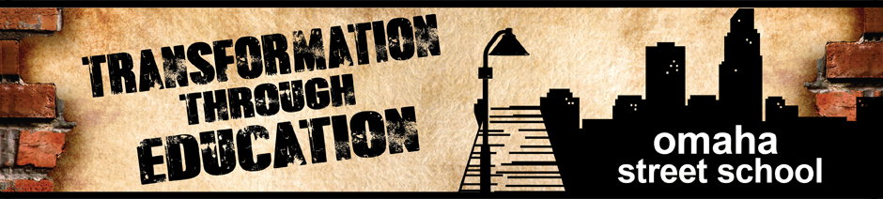
STATEMENT OF FAITH
We Believe:

...in the inspiration and authority of the Bible.

...in one God who is equal Father, Son and Holy Spirit.

...Jesus Christ is fully God and fully human; was crucified, died, buried and bodily resurrected to reconcile the world to God and give new life to those who by faith participate in His death and resurrection.

...the Holy Spirit convicts the world of sin, reveals Jesus Christ, gives the life of Christ to those who repent of sin and trust in Jesus and restores, sets apart for His purposes, and empowers those who believe.

...all persons are created in the image of God, designed for fellowship with God but are separated from God by sin and in need of salvation.

...all who receive the message of Jesus Christ are participants in His eternal life

...there is one universal Christian Church consisting of all who receive the good news of Jesus Christ.

...Christ will return, and all humans will be judged based on their acceptance or rejection of God’s salvation through Christ.

I, ____________________________________ have read the above-referenced paragraphs regarding the core tenets of the Omaha Street School, do hereby affirm this Statement of Faith, and if appointed to the Board of Directors, I agree as a part of my responsibilities to uphold and make decisions that are consistent with the mission and beliefs of the Omaha Street School.

Date _______________

